Graph Theory
By Wednesday midnight, post your answers to the following:
Research an application of Graph Theory in the real world. Find an article that describes how Graph theory is used, and what parts of Graph Theory are used. Explain why this application is important for science, business or your personal life with a post of at least 250 words. A picture/image that illustrates the concept would also be nice. Please cite your references.
Graph Theory is a very interesting topic which can be used in many real-world applications. One of the applications which I have seen in the past is the field of networking. In networking, we can use graph theory to identify relationships of nodes in a network and how they communicate. The physical layout of a network is called a topology.
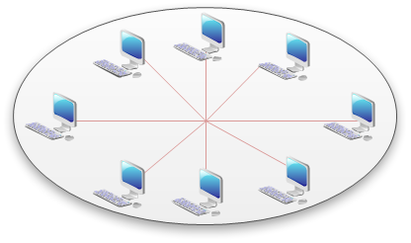
In the graph network nodes like switches, router, etc can be the vertices and link or media of data transfer can be considered the edges. Paths can be calculated using mathematics which can solve the fast path for data transfer within the network. By using graph theory in networks we can decide the best physical and logical network need and identify more effective network designs.
Having the ability to make networks my effective greatly improves many industries, such as telecommunication, the airline industry, etc, pretty much any industry which needs a means of faster communicate.

References:
https://www.plexxi.com/2014/08/graph-theory-calculating-network-topologies/

